Typing Behaviour: Prediction System

Project Id: AIML-5

Name : Shreshth Vardhan (Team Leader)
Class Roll Number: 69
University Roll Number : 2028853
Section and Group: K(G2)

Name : Mohammad Faizal
Class Roll Number: 54
University Roll Number : 2028767
Section and Group: K(G2)

Name : Rakshit Nath
Class Roll Number: 54
University Roll Number : 2028767
Section and Group: K(G2)

- Problem Description 3
- Architecture 4
- Models model 5
- Evaluation metrics used 6
- Preliminary Results and Visualizations 7
- References 9

- Problem Description
The Typing Behaviour Classification System is a machine learning-based project designed to analyze and classify user typing patterns using keystroke dynamics data. The dataset contains features such as key press duration, hold time, and flight time between keystrokes.
The objective of this project is to identify typing speed patterns and classify users into different categories (fast or slow typists). This system can be useful in applications like user authentication, behavioral biometrics, and performance analysis.
Machine learning techniques help automate the classification process by learning patterns from the data, reducing manual analysis and improving accuracy.

- Architecture

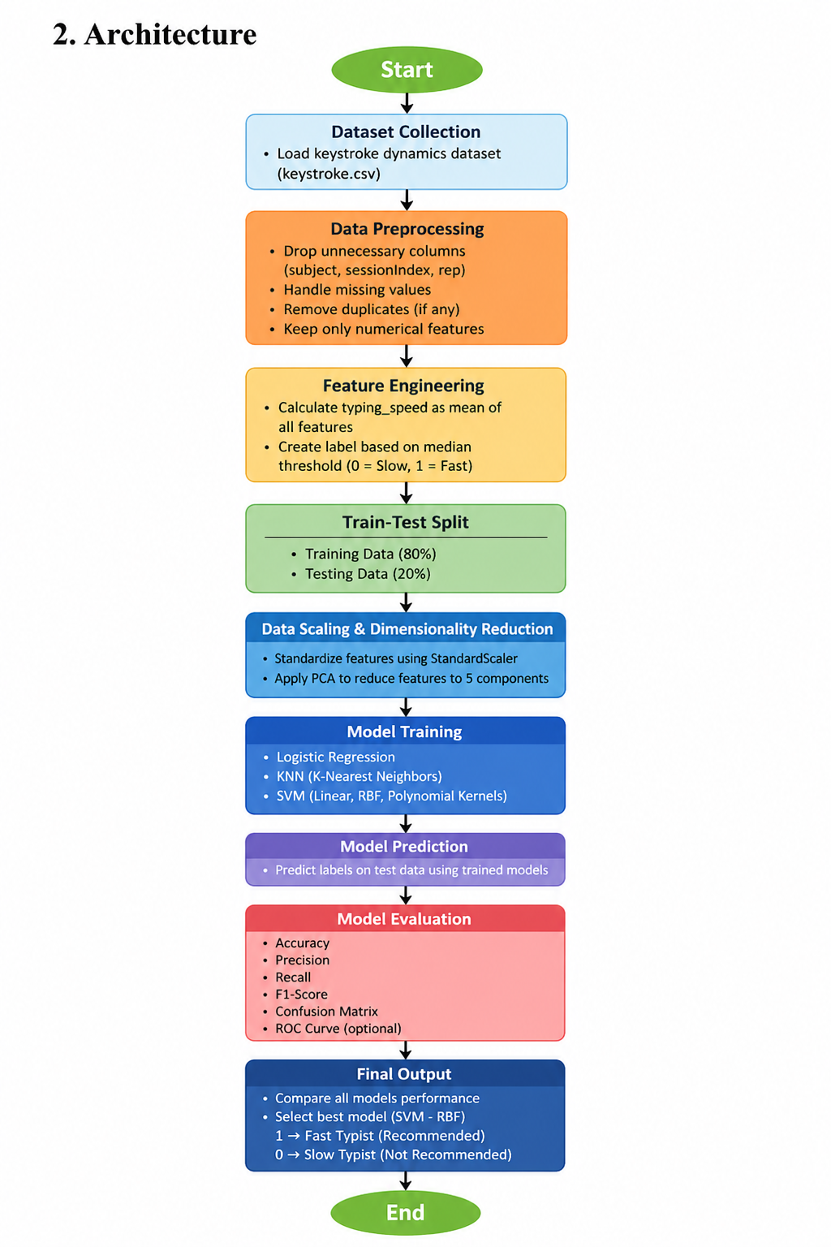

- Models Used(Applied/ Planned) Give a brief introduction of the models used

In this project, multiple machine learning models were applied to classify typing behavior into fast and slow typists based on keystroke dynamics data.

1. Logistic Regression
Logistic Regression is a supervised machine learning algorithm used for binary classification problems. It predicts the probability that a given input belongs to a particular class.
In this project:
- It is used to classify users as fast (1) or slow (0) typists
- Works well when data is linearly separable
- Provides high accuracy with simple implementation

2. K-Nearest Neighbors (KNN)
KNN is a non-parametric algorithm that classifies data points based on the majority class of their nearest neighbors.
In this project:
- It uses distance (Euclidean) to find nearest data points
- The value of K is set to 5
- It is simple but computationally expensive for large datasets

3. Support Vector Machine (SVM)
SVM is a powerful classification algorithm that finds the optimal hyperplane to separate different classes.
Different kernels used:
a) Linear Kernel
- Used when data is linearly separable
- Faster and simpler
b) RBF (Radial Basis Function) Kernel
- Handles non-linear data
- Provides best performance in this project
c) Polynomial Kernel
- Maps data into higher dimensions
- Useful for complex patterns but may reduce accuracy

4. Evaluation Metrics Used
The following metrics were used:
Accuracy
Accuracy measures correctly classified instances.
Formula:
Accuracy = (TP + TN) / Total Predictions
Precision
Precision measures how many predicted positives are correct.
Recall
Recall measures how many actual positives are correctly identified.
F1-Score
F1-score gives balance between precision and recall.
Confusion Matrix
Shows correct and incorrect predictions.

5. Preliminary Results and Visualizations

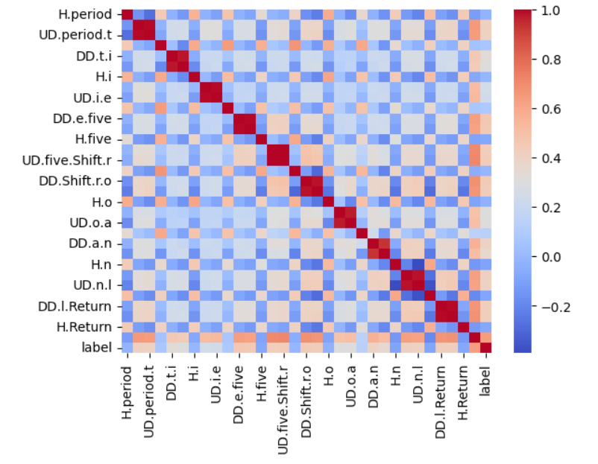

Fig.2 Heatmap showing corelation.

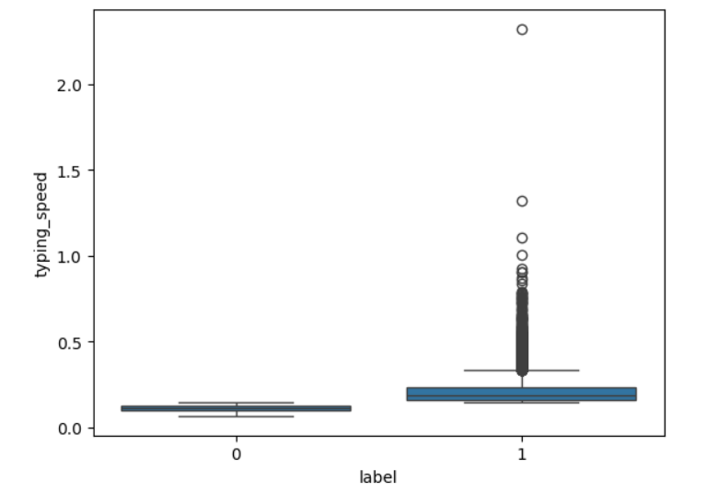

Fig 3 Boxplot

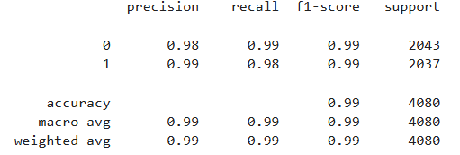

Fig 4 confusion matrix

6. References:
Books:
- Let Us Python – Yashavant Kanetkar

Online Resources:
  - GeeksforGeeks – https://www.geeksforgeeks.org/
  - TutorialsPoint – https://www.tutorialspoint.com/cprogramming/index.htm
  - Stack Overflow – https://stackoverflow.com

